Embedded C programming

- Write a program to set (enable) the 5th bit of a 32-bit registar.
#include <stdio.h>
#include <stdint.h>

int main() {
uint32_t my_register = 0x00000000;

int bit_position = 5;

my_register |= (1 << bit_position);

printf("Register value after setting 5th bit: 0x%08X\n", my_register);

return 0;
}

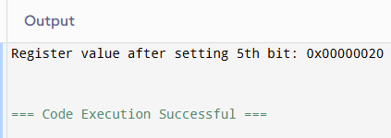

- Write a program to clear the 2nd bit of a 16-bit register.-0000 0100.

#include <stdio.h>
#include <stdint.h>

int main() {
uint16_t reg = 0x0004;

int bit_position = 2;

printf("Before clearing: 0x%04X\n", reg);

reg &= ~(1 << bit_position);

printf("After clearing: 0x%04X\n", reg);

return 0;
}
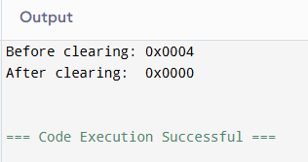

3.write a program to count the number of set bits (1s) in a number.

#include <stdio.h>

int countSetBits(int n) {
int count = 0;
while (n > 0) {
n &= (n - 1);
count++;
}
return count;
}

int main() {
int num;
printf("Enter a number: ");
scanf("%d", &num);

printf("Number of set bits (1s): %d\n", countSetBits(num));
return 0;
}
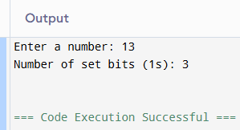

4.write a program to check whether a given bit position is set or not.(4th bit)

#include <stdio.h>

int main() {
int number;
int bit_position = 3;

printf("Enter an integer: ");
scanf("%d", &number);

if (number & (1 << bit_position)) {
printf("The 4th bit is SET (1).\n");
} else {
printf("The 4th bit is NOT SET (0).\n");
}

return 0;
}
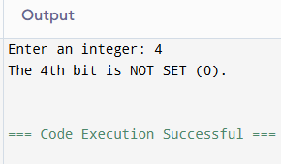

5.write a program to count the number of set bits(1s) in a number.
#include <stdio.h>

int countSetBits(int n) {
int count = 0;
while (n > 0) {
n &= (n - 1);
count++;
}
return count;
}

int main() {
int num;
printf("Enter an integer: ");
scanf("%d", &num);

printf("Number of set bits (1s) in %d is: %d\n", num, countSetBits(num));

return 0;
}
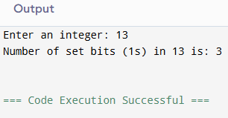

6.write a program to perform left shift and right shift operations on a number and display result.
#include <stdio.h>

int main() {
int num, shift;

printf("Enter an integer: ");
scanf("%d", &num);
printf("Enter number of bits to shift: ");
scanf("%d", &shift);

int leftResult = num << shift;

int rightResult = num >> shift;

printf("\nOriginal Number: %d", num);
printf("\nLeft Shift (%d << %d): %d", num, shift, leftResult);
printf("\nRight Shift (%d >> %d): %d\n", num, shift, rightResult);

return 0;
}
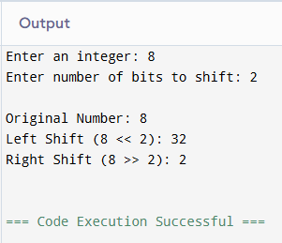

7.write a program to swap two numbers using bitwise XOR
#include <stdio.h>

int main() {
int a, b;

printf("Enter two integers: ");
scanf("%d %d", &a, &b);

printf("\nBefore swapping: a = %d, b = %d\n", a, b);

a = a ^ b;
b = a ^ b;
a = a ^ b;

printf("After swapping: a = %d, b = %d\n", a, b);

return 0;
}
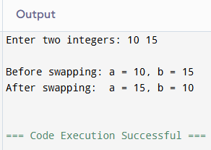

8.write a program to clear all bits except a specific bit position.
#include <stdio.h>

unsigned int clear_all_except_pos(unsigned int num, int pos) {
return (num & (1 << pos));
}

int main() {
unsigned int number = 0b10110110;
int position = 4;

unsigned int result = clear_all_except_pos(number, position);

printf("Original number: 0x%X\n", number);
printf("Preserving position: %d\n", position);
printf("Resulting value: 0x%X\n", result);

return 0;
}
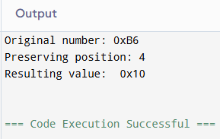

9. Write a program to blink an led connected to pin number 2 of a microcontroller . use software delay.
#include <reg51.h>

// Define LED connected to Pin P2.0
sbit LED = P2^0;

// Software delay function
void delay()
{
int i, j;
for(i = 0; i < 500; i++)
{
for(j = 0; j < 500; j++);
}
}

void main()
{
while(1)
{
LED = 1; // Turn LED ON
delay();

LED = 0; // Turn LED OFF
delay();
}
}

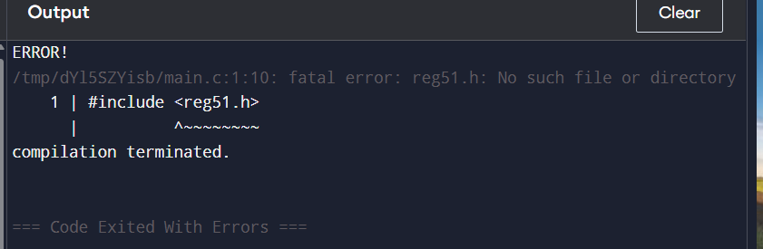

10.Write an embedded c program to check the temperature . If it is more than35 degree centigrade send high signal to fan so that it can turn on.
#include <stdio.h>

int main()
{
float temp;

printf("Enter temperature in degree centigrade: ");
scanf("%f", &temp);

// Check temperature
if(temp > 35)
{
printf("Temperature is high\n");
printf("Fan Signal = HIGH\n");
printf("Fan Turned ON\n");
}
else
{
printf("Temperature is normal\n");
printf("Fan Signal = LOW\n");
printf("Fan Turned OFF\n");
}

return 0;
}

